

**Tribhuvan University**

**Faculties of Humanities and Social Sciences**

**HOSTEL MANAGEMENT SYSTEM**

**A PROJECT PROPOSAL**

**Submitted to**

**Department of Computer Application**

**Ratna Rajya Laxmi Campus**

***In partial fulfillment of the requirements for Bachelors in Computer Applications***

**Submitted by**

**Sagar Adhikari (6-2-40-50-2020)**

Under the Supervision of

**Bhupendra Ram Luhar**

**Table of Contents**

1. Introduction 1

2. Problem Statement 2

3. Objectives 2

4. Methodology 3

a. Requirement Identification 3

i. Study of an Existing System 3

ii. Literature Review 4

iii. Requirement Analysis 5

b. Feasibility Study 6

i. Technical Study 6

ii. Operational Study 6

iii. Economic Study 6

c. High Level Design of System 7

i. Methodology 7

ii. Flowchart 8

iii. Description of Algorithm 9

5. Gantt Chart 10

6. Expected Outcomes 10

References 11

# Introduction

The advancement of technology has evolved almost all sectors, including the hostel. The old technique of performing tasks of hostel manually, has evolved to the online system which has led to development of Hostel Management System (HMS). Hostel Management System is developed with the objective of automating tasks of hostel such as registration form, assigning rooms, updating user's details and so on. This particular project also solves the problem with the data in hostel by reducing redundant data of users, manually updating users' data in registers. Identification of the drawbacks of the existing system leads to the designing of computerized system that will be compatible to the existing system with the system which is more user friendly.

This system offers a centralized platform where users can explore, compare, and book hostels among multiple options available, providing detailed information on hostel facilities, room types, pricing, availability, and user reviews. Key features include multi-hostel search and comparison, real-time availability and booking, user reviews and ratings. Users can search for hostels based on various criteria, compare options side-by-side. The real-time availability feature allows for instant booking, reducing the hassle of overbooking.

The Hostel Management System stands as a transformative solution in the realm of accommodation services, effectively bridging the gap between user expectations and administrative efficiency. By providing a centralized, user-friendly platform with real-time information, secure payment options, and comprehensive management tools, the system ensures a seamless experience for both hostel guests and administrators. The integration of user reviews and ratings fosters a transparent and trustworthy environment, while the robust admin dashboard empowers hostel managers with valuable insights and streamlined operations. This innovative approach not only enhances the convenience and reliability of booking hostels but also sets a new standard for efficiency and customer satisfaction in the hospitality industry.

# Problem Statement

Various Hostel Management Systems are available, but some flaws make them. Poor room allocation often leads to suboptimal room assignments, causing dissatisfaction among users and underutilization of available space. The current hostel management system lacks an efficient room booking feature, leading to frequent issues with overbooking and confusion regarding room availability. The current challenge is the lack of a user-friendly system that enables users to easily compare prices among different hostels, leading to inconvenience and difficulty in making informed decisions about accommodation options.

# Objectives

The Hostel Management System is developed with the aim of completing following objectives:

* To implement a system that allows users to book rooms and provides real-time information about
* To develop a system with a good UI that helps in comparing prices among different hostels.

# Methodology

## Requirement Identification

### i. Study of an Existing System

To explore more about hostel management systems, a broad study of systems such as hostelworld, hostelz were conducted. Every of these platforms have their own features, characteristics along with some drawbacks as well.

Hostelz allows to find hostel around the world in single click. Along with that, it also allows the comparing of the price of the hostels. It offers an simple and fascinating User Interface (UI) which allows the user for the better experience when interacting with the website. [1]

Agoda makes the task of the user easy by helping them find the hostel very comfortably. It offers a range of accommodation options, including hostels, with user reviews and competitive pricing. Along with that, it also allows the users to list their own place for other users. It eases the user task as they can book hostel based on the reviews. [2]

Hostelworld is another platform for booking hostel in an easy manner. It allows easy booking and flexible cancellation as well. It provides lower and competitive price among the websites, so that user can book the hostel at minimum cost. It provides easy and interactive UI for easy interaction for the user. [3]

Hostelling International's mission is to provide affordable, safe, and quality accommodation for travelers, particularly young people, to encourage cultural exchange and foster global understanding. HI hostels provide budget-friendly accommodations, making travel more accessible to young people, students, and backpackers. Hostels often organize activities and events that encourage interaction between guests from different cultures, such as city tours, cultural workshops, and communal meals. Hostelling International (HI) provides a reliable and affordable option for seeking quality accommodation. [4]

### ii. Literature Review

The literature review for this project involved a depth exploration of existing research papers, articles and journals related to Hostel Management System (HMS). In addition to that broad research was conducted on existing platforms such as Hostelz, HostelWorld and so on. These platforms provide a significance knowledge for the development of the hostel management system. As is well-known, the education institutions are rapidly increasing for the past few years. Therefore, it leads to mushrooming of hostels for the accommodation of the student’s study in these institutions. And hence there is the appearance of Hostel Management System which helps with dealing the problem of managing hostel and avoid the problem when do it manually.

By studying findings from the literature review and analysis of existing systems, I gained

valuable insights that helped me in the design and development of Learning Management

System. These insights include understanding the importance of flexibility, user engagement, content quality, and the need for both structured and self-paced learning options.

Successful implementations of HMS have significantly improved hostel operations and student satisfaction by reducing manual errors and providing real-time data access. For example, Kumar studied the implementation of an HMS in a university hostel and found that the system significantly improved the management of hostel operations, reduced manual errors, and enhanced overall student satisfaction. [5]

Computerized HMS streamline operations, improve accuracy, and enhance user experience through features such as automated room allocation, online fee payment, centralized student information systems, visitor management, and complaint tracking. They developed a web-based HMS that allowed for online room booking, fee payment, and student information management. Their system reduced administrative workload and enhanced user experience by providing a user-friendly interface. [6]

### iii. Requirement Analysis

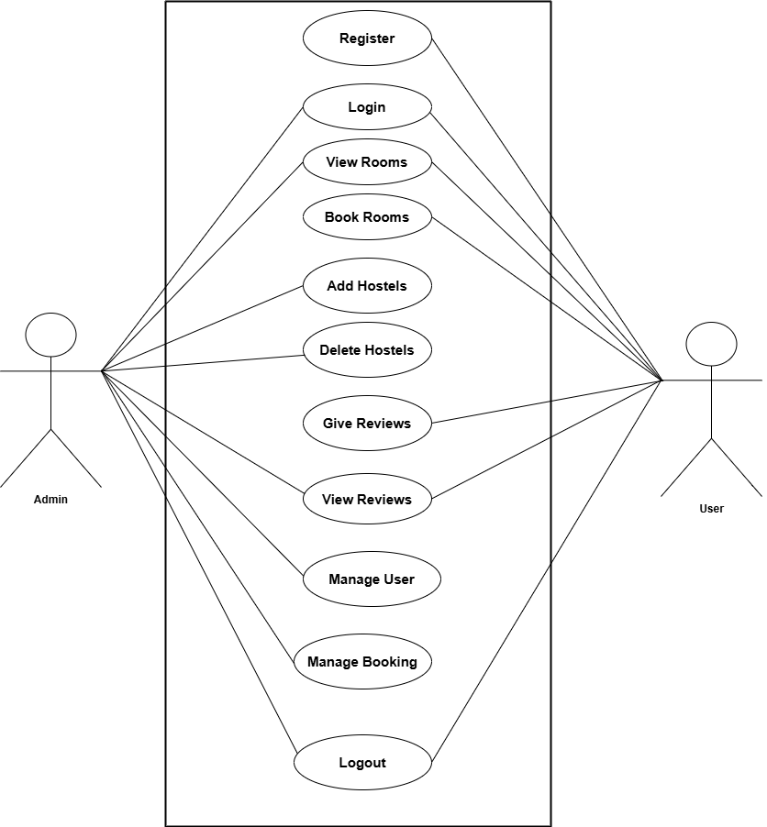**Functional Requirements**

**Figure 1: Use Case Diagram of Hostel Management System**

Users are allowed to register, login and logout from their account. Along with that they can view available rooms, book them and give reviews about the rooms and can view the reviews as well.

Admin can login and logout from the account. Admin can add hostels and delete hostels. Admin can manage the registered users and bookings and can view the reviews provided by the student as well.

## Feasibility Study

### i. Technical Study

The proposed system for this project is technically feasible because it will not require any extra or high-functioning devices, and the maintenance of the system will be easier as well.

### ii. Operational Study

The proposed system for this project is operationally feasible because it is very user friendly for the Users to use and the admin can operate it after they are provided with the basic training.

### iii. Economic Study

The proposed system for this project is simple and cost-efficient and no further big changes would be required so it is economically feasible. It is suitable for low-budget organization as well.

## c. High Level Design of System

### i. Methodology

For the development of Hostel Management System (HMS), we'll be using the Waterfall Model as the requirements are pre-known. In this methodology we will move to next step only after completing the current step. This methodology includes steps such as Requirement Gathering, System Design, Implementation, Testing and Deployment. The waterfall approach is used when the requirements are known at the beginning of the project.

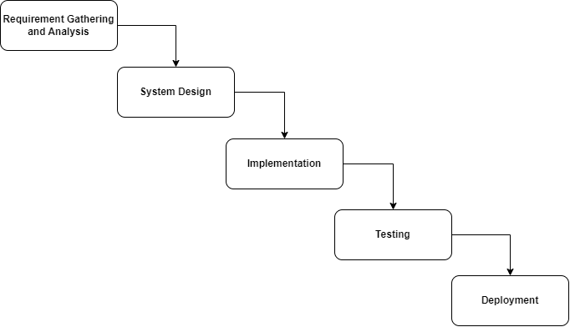

**Figure 2: Waterfall Model**

### ii. Flowchart

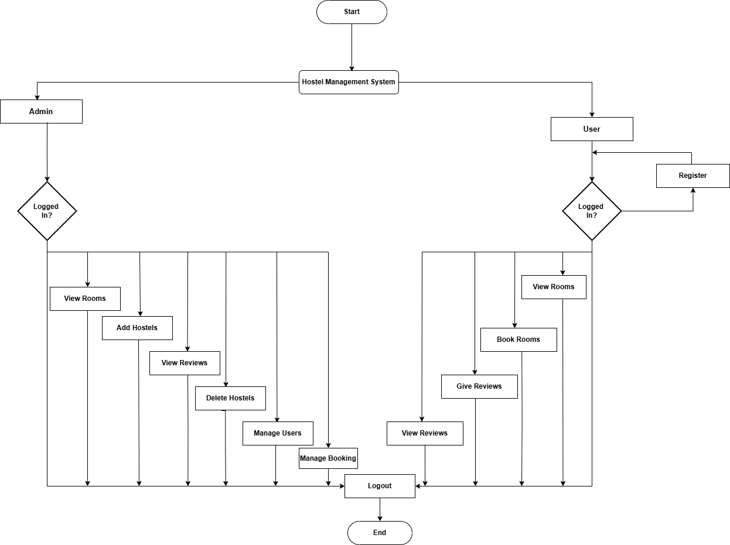

**Figure 3: Flowchart of Hostel Management System**

The flowchart depicts the flow of the proposed system. The flowchart starts with two modules admin and user. Admin first of all have to login to the system with valid credentials and can add hostel, delete hostel and can manage user and can manage booking as well. In context of user, user also have to login to the system, if not user have to register to the system to get access to the system. After that, user can book rooms, view rooms, view reviews and can give reviews as well.

### iii. Description of Algorithm

The K-Nearest Neighbors (KNN) algorithm is instrumental in recommending nearby hostels to users based on their current geographic location. Each hostel is represented as a data point in a multidimensional space defined by its latitude and longitude coordinates. When a user queries the system for nearby accommodations, their location serves as the query point. The algorithm calculates the distance between the user's location and each hostel using distance metrics like Euclidean or Haversine distance for geographic accuracy. Hostels are then sorted based on proximity, and the K nearest hostels determined by the user's specified K value are recommended.

$$d\left(p,q\right)=\sqrt{\sum_{i=1}^{n}{{\left(q_{i}-p_{i}\right)}^{2}}}$$

Here,

* p represents the user location.
* q represents the hostel location.
* n is the number of dimensions (usually 2 for latitude and longitude).
* The summation $\sum_{i=1}^{n}{ }$ adds up all the squared differences for each dimension I from 1 to n.
* The square root $\sqrt{.}$ gives the Euclidean distance.

# 5. Gantt Chart

**Figure 4: Gantt Chart**

# 6. Expected Outcomes

Implementing the Hostel Management System is expected to bring several positive outcomes. It will make tasks like assigning rooms, getting real time information about rooms. By automating these tasks, it will reduce the workload for staff and cut down on mistakes in resident details. Overall, these improvements should lead to a smoother experience for residents, clearer administrative decisions, and higher satisfaction levels in the hostel. Along with that, the system provides easy user interface to interact with and also helps to compare the price of the hostels across different places. The developed system aims to provide easy and simple interface to book hostel according to the requirements.

# References

|  |  |
| --- | --- |
| [1] | "Hostelz," [Online]. Available: https://www.hostelz.com/. [Accessed 06 July 2024]. |
| [2] | "Agoda," [Online]. Available: https://www.agoda.com/. [Accessed 6 July 2024]. |
| [3] | "HostelWorld," [Online]. Available: https://www.hostelworld.com/. [Accessed 06 July 2024]. |
| [4] | "Hostelling International," [Online]. Available: https://hihostels.com/. [Accessed 8 July 2024]. |
| [5] | K. K. M. R. P. Reddy, "Effectiveness of Hostel Management System in College Hostels," *International Journal of Advanced Research in Computer Science and Software Engineering,* pp. 104-109, 2019. |
| [6] | R. G. S. Gupta, "A Web-Based Hostel Management System," *Journal of Software Engineering and Applications,* pp. 159-165, 2016. |